Group A
1. (a) Definition of Law.
Ans: Law is a rule of conduct developed by the government or society over a certain territory. Law follows customs in order to deal with crime, business, social, relationship, property and finance etc.
(b) Classification of Law.
Ans: i. Criminal Law, ii. Civil Law, iii. Constitution Law, iv. Administration Law (i. Substrative law, ii. Procedural law)
(c) Define Source of Law.
Ans: Source of law means the origin from where laws get their authority such as the constitution, law, customs and judicial decision.

2. (a) Define Purpose of law.
Ans: The law serves many purposes. Four principal ones are establishing standards, maintaining order, resolving disputes and protecting liberties and rights.
(b) Advantage and Disadvantage of Law.
Ans: Advantage of Law:
i. Protection of rights of an individual.
ii. Determine the duties
iii. Prevention of crime.
iv. Punishment of the accused.
v. Making rules for smooth functioning.

Disadvantage of Law:

i. Legal processes are often slow and time-consuming.
ii. Law can be expensive, especially court cases and lawyers.
iii. Complex language of law is difficult for common people to understand.
iv. Sometimes laws become outdated.

Group B
1. Compositions and functions of United nations (6 organ of United nations)
Ans: The United Nations is an international organization established in 1945 to maintain world peace and promote cooperation among nations. It has six principal organs.
1. General Assembly
2. Security Council
3. Economic and Social Council
4. International Court of Justice
5. Secretariat
6. Trusteeship Council
Their composition and functions are given below:
Function:
i. Discusses international issues
ii. Makes recommendations
iii. Approves the UN budget
iv. Elects members of other organs
5. Secretariat:
Composition:
i. Lead by Secretary-General
ii. Thousands of international staff

4. International Court of Justice:
Composition:
i. 15 judges
ii. 9-years term
iii. Located in the Hague, Netherlands
3. Economic and Social Council:
Composition:
i. 54 members
ii. Elected for 3 years
2. Security Council:

Composition:

i. 15 members
- 5 permanents (USA, UK, France, Russia, China)
- 10 non-permanent (2-year term)
ii. Permanent member have veto power.
1. General Assembly:
Composition:
i. All 193 member countries
ii. Each country = 1 vote

Function:
i. Maintains international peace & security
ii. Settles disputes
iii. Authorizes military action
iv. Sends peacekeeping forces

Function:
i. Promotes economic growth
ii. Improves education, health, and human rights
iii. Coordinates agencies (WHO, UNESCO, UNICEF etc.)
iv. Research and development work

Function:
i. Settles legal disputes between states
ii. Gives legal advice
iii. Interprets international law

Function:
i. Runs daily UN operations
ii. Organizes meetings
iii. Prepares reports

6. Trusteeship Council:
Composition:
i. Originally included trust territory administrators
ii. Now mostly inactive
Function:
i. Supervised trust territories
ii. Currently inactive

2. Court Structure of Bangladesh (Legal System of Bangladesh)
Ans: The legal system of Bangladesh is an interesting blend of history and structure. It is primarily a Common Law system. The judiciary is designed to be independent, acting as the guardian of the Constitution. Here is how the "House of Justice" is built in Bangladesh:
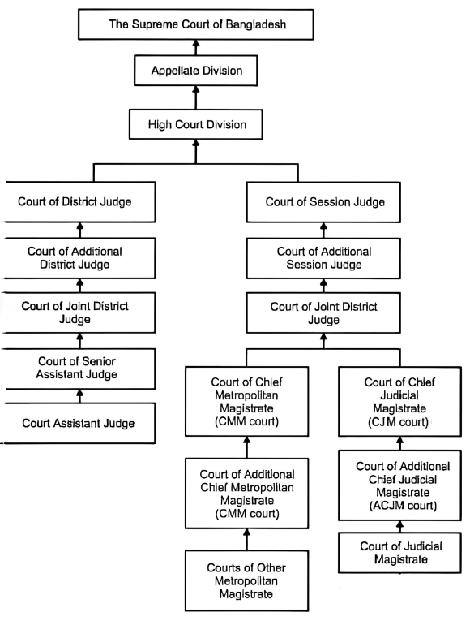
Court System of Bangladesh

Court of Session Judge

3. Rites of Bangladesh
Ans: Rites mean special customs, traditions, or ceremonies that people follow in their life. In Bangladesh, different rites are practiced based on religion, culture, and society.
4. Death Rites
- Special religious rules are followed after death.
- Muslims perform Janaza prayer and burial.
- Hindus cremate the dead body.
- Family members pray for the soul.
5. Festival Rites
- People celebrate religious festivals with rituals.
- Eid, Durga Puja, Christmas, Buddha Purnima etc.
- Visiting relatives, sharing food, and praying are common customs.
1. Birth Rites
- Family celebrates when a baby is born.
- Naming ceremony is held.
- Hindu families arrange naming and blessing ceremony.
2. Education Rites
- Children start education with a special ceremony.
- Muslims say Bismillah.
3. Marriage Rites
- Marriage is a big social event.
- Muslim marriage is done by Nikah.
- Hindu marriage follows Vedic ceremony and fire ceremony.
- Relatives and friends join the celebration.

4. Explain Three generation of Human Rights and difference Fundamental and Human Rights.
Ans: i) First generation of human rights is represented by civil and political rights. ii) The Social, economic and cultural rights are equated with the Second generation. iii) Collective or Solidarity rights are third generation.
Fundamental Rights vs Human Rights:
Fundamental Rights | Human Rights
1. Basic rights given by the Constitution of a country | 1. Basic rights given to all humans by birth
2. Given by Government/Constitution | 2. Given by Nature and international law
3. Area only for citizens of a specific country | 3. Area for all people of the world
4. Law source National Constitution | 4. International laws like United Nations
5. Court protection can go to court if violated | 5. May not always get legal protection in every country.
6. Example: Rights to vote, right to equality, freedom of speech. | 6. Example: Right to life, food, shelter, education

5. Fundamental Rights (Articles 26-47) of the Bangladesh Constitution
Ans: Fundamental rights are the basic rights of citizen. They protect freedom, equality and justice. If these rights are violated, we can go to court.
Articles 26-47:
🔹 Article 26 – Supremacy of Fundamental Rights
🔹Article 27 – Equality before Law
🔹Article 28 – No Discrimination
🔹Article 29 – Equal Opportunity
🔹 Article 30 – No Foreign Title
🔹 Article 31 – Protection of Law
🔹 Article 32 – Right to Life and Liberty
🔹 Article 33 – Safeguards on Arrest
🔹 Article 34 – No Forced Labor
🔹 Article 35 – Protection in Trial

🔹 Article 36 – Freedom of Movement
🔹 Article 37 – Freedom of Assembly
🔹 Article 38 – Freedom of Association
🔹 Article 39 – Freedom of Thought and Speech
🔹 Article 40 – Freedom of Profession
🔹 Article 41 – Freedom of Religion
🔹 Article 42 – Right to Property
🔹 Article 43 – Privacy of Home and Communication
🔹 Article 44 – Enforcement of Rights
🔹 Article 45–47 – Special provisions

Article’s 26-47 of the Constitution of Bangladesh guarantee equality, freedom, justice and protection of citizens. These fundamental rights help people live with dignity and security.

Group C
1. (a) The relation between Law and Ethics.
Ans: Law - Law is a set of rules made by the government. People must follow the law. If someone breaks the law, gets punishment.
Ethics – Ethics means moral values. It tells us what is right and wrong. Ethics comes from society, religion and personal beliefs.
Relation between Law and Ethics:
1. Both guide human behavior: Law and ethics tell people how to behave properly.
2. Both try to create justice : They help to make society fair and peaceful.
3. Ethics influences law : Many laws are made based on moral values.
4. Law is stronger than ethics : Breaking law brings punishment, but breaking ethics may only collect social comment.
5. They support each other : Good laws are usually based on good ethics.
Law and ethics are closely related. Ethics guides moral behavior and law makes rules based on those moral values. Both are important for a peaceful and just society.

(b) Difference Law and Ethics.
Law | Ethics
1. Law is rules made by the government. | 1. Ethics is moral values about right and wrong.
2. Comes from constitution and government. | 2. Comes from society, religion, and personal beliefs.
3. Law is written and official | 3. Ethics may not be written
4. Law is compulsory for everyone | 4. Ethics is not legally compulsory
5. Example: Traffic rules, criminal law | 5. Example: Honesty, respect, kindness

2. Activities of NSPE (National Society of Professional Engineers).
Ans: The National Society of Professional Engineers (NSPE) is professional organization for engineers. It works to protect engineers and promote ethical practices.
Activities of NSPE:
i. Protecting public safety.
ii. Only performing tasks they are qualified to do
iii. Being honest in public communications
iv. Remaining faithful and dependable to employers
v. Acting with integrity.
NSPE works to promote ethical behavior, protect public safety and support professional development of engineers. It plays an important role in improving the engineering profession.

3. AS a Engineer, what will be your responsibility to society and the environment?
Ans: As an engineer, I have many responsibilities to society and the environment. Engineering work affects people’s life, safety, and nature. So, I must follow both law and ethics in my profession.
Responsibility to Society:
1. Protected Public Safety:
My first duty is to protect the health, safety, and welfare of people. I must design safe buildings, bridges,
roads and machines.

2. Follow the Law:
I must follow government rules and standards. I should not break any legal regulations.

3. Work Honestly and Fairly:
I must be truthful in my work. I should not take bribes or do Corruption.

4. Provide Quality work:
I must give correct information and good service. I should not use poor materials or false data.

5. Respect Human Rights:
I should respect equality and dignity of all people.

Responsibility to the Environment:

1. Protect Nature:
I must reduce pollution and waste.

2. Use Resources Wisely:
I should save water, energy, and natural resources.

3. Promote Sustainable Development:
My projects should not harm future generations.

4. Follow Environmental Laws:
I must obey environmental protection rules.

5. Create Eco-friendly Designs:
I should design projects that are safe for the environment.

An engineer has both legal and ethical responsibilities. I must protect society, follow the law, work honestly, and care for the environment. By doing this, I can help build a safe, fair, and sustainable world.

